PitStop turttle tag case – Assembly instructions

1. Step: Position electronics and battery into the case. To secure it use silicone, also we recommend to pour layer of silicone on top of electronics to additionally waterproof the system.
2. Step: Mount lid with polyurethane gasket using 14 DIN 7991 M4X12mm screws. Use provided allen key found in a bag with screws. Use longer side of a allen key as a lever. Proceed with screewing in a sequence shown in picture. Tighten screws only when all screws are prescrewed, follow the same sequence when tightening. You should tighten as much as possible using just longer level of allen key that we provided. If using longer allen key are excessive force when screwing the acrylic case can crack or head of the screw can be damaged.

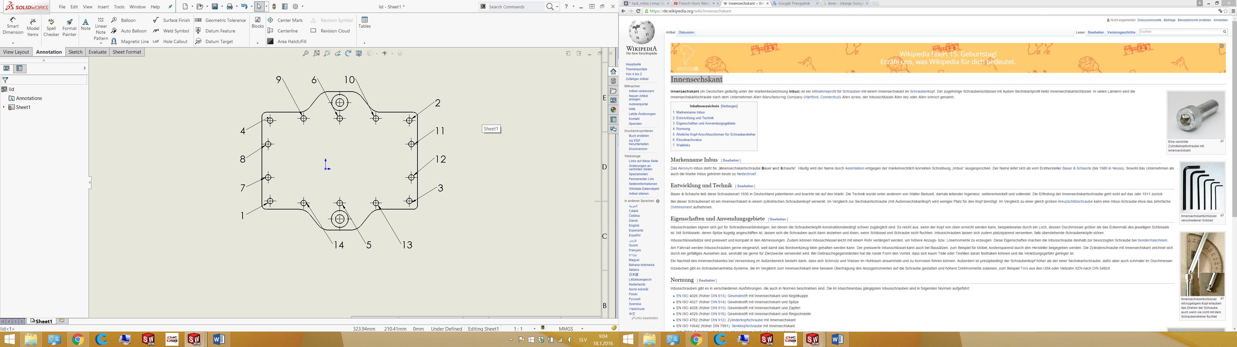

1. Step: Using 2 DIN 7991 M6x10mm screws and provided allen key, screw case with lid onto Base plate. Base plate should be positioned in a way so pocket is facing downwards:



1. Step: Roughen the bottom surface of the aluminum base plate (surface where epoxy is applied) using screwdriver or other sharp tools.

Before:

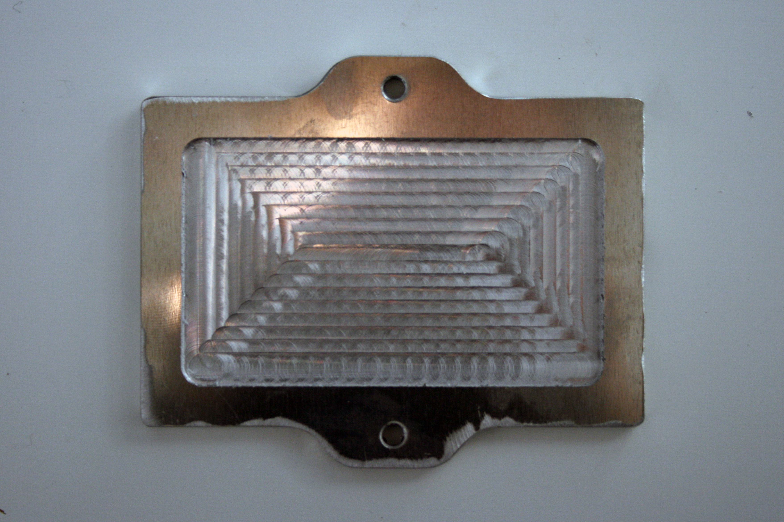

After:

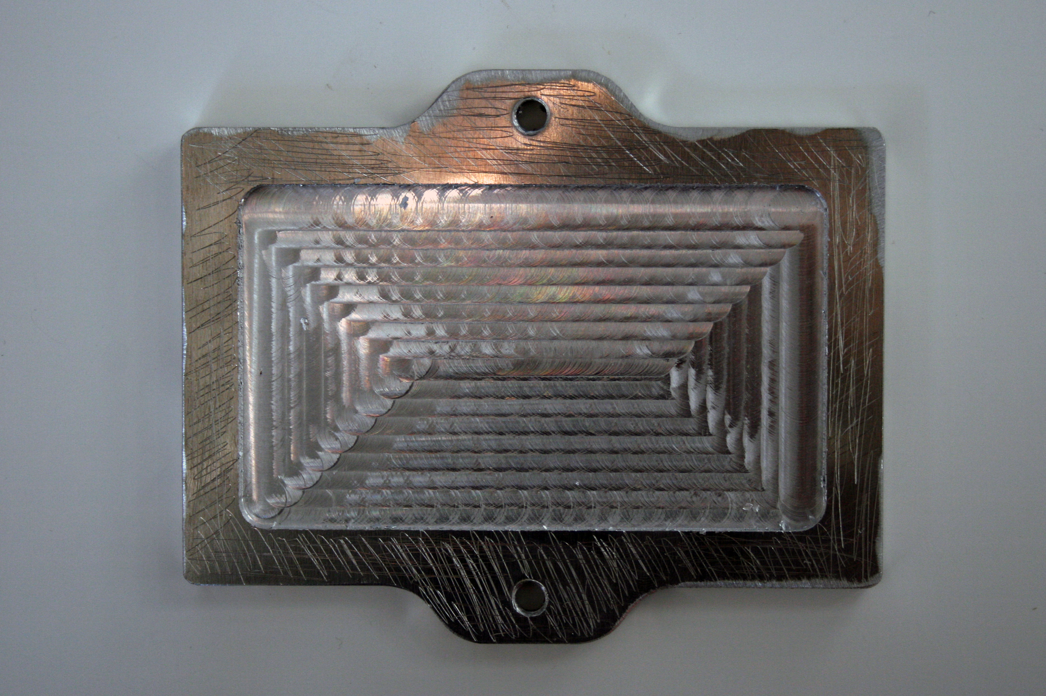

1. Step: Clean roughen surface with alcohol and prepare it for gluying.